TOPIC #: 3 DATE:18/03/2025
PROMPT: “Reflect on the nature of ‘equality’ in the year 2081. How does this compare (or contrast) with what we usually think of human ‘equality.’“
This week we were presented with a distorted question in my opinion. I believe that I was faced with a story about a very dark and depressing depiction of ‘equity’ and told it was about ‘equality’. Back in Portugal I had learned the difference between these two words, a minute but a very important difference, because I as a child with a disability had a hard time accepting the idea that it was okay to ask for more time to finish a text, that it was okay to have different evaluation methods. I always thought it was unfair for my colleagues. Why did I deserve help, to be above them? Until one day I saw a picture that explained in the most simple way possible the difference between ‘equality’ and ‘equity’. (I have attached a similar picture below) This picture changed my life. With the help of one simple picture my guilt finally disappeared and I was finally able to see what was happening. I wasn’t creating injustice by being put on a level playing field with others. It was fair, it was equity. That’s why I believe Harrison Bergeron is a story about a dark and twisted perspective on equity, because instead of giving more boxes to the shorter person, the author presents a world where the solution for this situation would be to take away everyone's boxes and then make holes in the ground so everyone would be “equally” unable to see the game. This was never ‘equality’ and I believe this was never even ‘equity’ because equity is fair, equity isn’t about making anyone’s life worse equity is about giving everyone as much as they need to have the same possibilities as everyone else. So in a shorter answer there is no shadow of equality in Harrison Bergeron but there is a twisted and depressing image of equity.
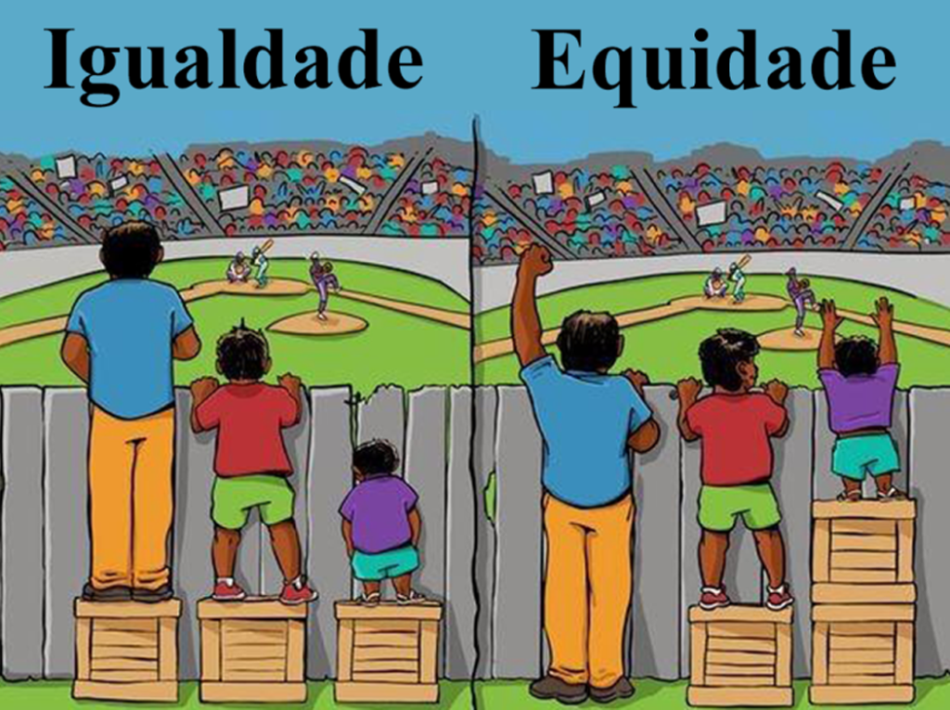
(Igualdade means Equality and Equidade means Equity)

